**MEDICAPS UNIVERSITY**

**INDORE**



**Department of Computer Science & Engineering**

**FACULTY OF ENGINEERING**

**Practical File**

**Software Engineering [CS3CO26]**

|  |  |  |
| --- | --- | --- |
| **Submitted To:** |  | **Submitted By:** |
| Mrs. Maya Yadav |  | Prakhar Agrawal |

EN21CS301564 CS-J

|  |  |  |  |  |  |
| --- | --- | --- | --- | --- | --- |
| S.no. | Name of Practical | Date of Experiment | Date of Submission | Page no. | Remark |
|  |  |  |  |  |  |
|  |  |  |  |  |  |
|  |  |  |  |  |  |
|  |  |  |  |  |  |
|  |  |  |  |  |  |
|  |  |  |  |  |  |
|  |  |  |  |  |  |
|  |  |  |  |  |  |
|  |  |  |  |  |  |
|  |  |  |  |  |  |
|  |  |  |  |  |  |
|  |  |  |  |  |  |
|  |  |  |  |  |  |
|  |  |  |  |  |  |

# EXPERIMENT 1

# AIM: - To identify different types of software with their examples.

|  |  |  |  |  |
| --- | --- | --- | --- | --- |
| **S.NO** | **Name Of Software & Launching year** | **Domain** | **Technology Used** | **Key Features** |
| 1 | What’s app, launched in 2009 | Communication | Erlang, FreeBSD, PHP, XMPP, MySQL | * End-to End encryption * Privacy * User Friendly GUI |
| 2 | Spotify, launched in 2021 | Music streaming | Java, Python, Node.js, Apache Cassandra | * To listen music anytime, anywhere * Largest music streaming |
| 3 | BJYU , launched in 2011 | Educational | BlueJeans, Exotel, HTML5, jQuery, Google Analytics | * Wide range of courses * Top faculties * One to one interaction |
| 4 | Truecaller, launched in 2009 | Call search | HTML5, Google Analytics, Google Fonts | * It is used for caller-identification ,chat and voice by using internet * It requires user to provide a standard cellular mobile number for registering with the service |

|  |  |  |  |  |
| --- | --- | --- | --- | --- |
| 5 | Amazon, launched in 2011 | E-commerce delivery | Java, MySQL, DynamoDB, AngularJS and AWS | * Vast product selection * User-friendly website and MobileApp * One-click ordering * AmazonPay * Wish Lists and Registries |
| 6 | Phone pe, launched in 2015 | Payment app | HTML5, jQuery, Google Analytics | * Fund transfer * Recharge and bill payment * Easy interface phonepe has an easy interface |
| 8 | LinkedIn, launched in 2003 | Social networking | Algolia, Cherokee, Microsoft Windows Phone | * To develop professional network * To search jobs and internships |
| 9 | Netflix, launched in 2016 | Streaming Entertainment | Streaming Entertainment | * On-Demand Streaming. * Original Content. * Personalized Recommendations. * Offline Viewing. * Multiple Device Support. * Parental Controls. |
| 10 | Instagram, launched in 2010 | Social media platform | Python(Django), HTML5 and Javascript. | Instagram user can edit and upload images and short videos using smart phone app |

**EXPERIMENT 2**

**AIM: - To perform the user’s view diagram for suggested system: Use Case Diagram.**

A use case diagram is used to represent the dynamic behavior of a system. It encapsulates the system's functionality by incorporating use cases, actors, and their relationships. It models the tasks, services, and functions required by a system/subsystem of an application. It depicts the high-level functionality of a system and also tells how the user handles a system.

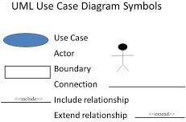

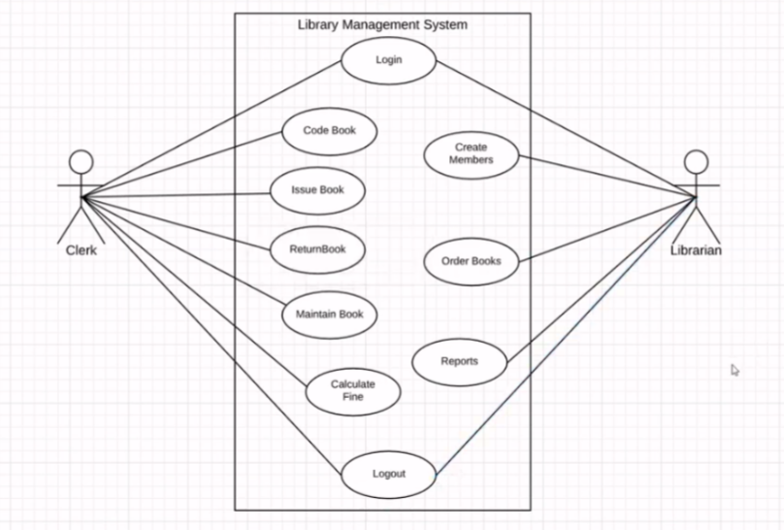

**EXPERIMENT 3**

**AIM: - To perform the class diagram for suggested system: Sequential Diagram**

The sequence diagram represents the flow of messages in the system and is also termed as an event diagram. It helps in envisioning several dynamic scenarios. It portrays the communication between any two lifelines as a time-ordered sequence of events, such that these lifelines took part at the run time. In UML, the lifeline is represented by a vertical bar, whereas the message flow is represented by a vertical dotted line that extends across the bottom of the page. It incorporates the iterations as well as branching.

## **Purpose of a Sequence Diagram**

1. To model high-level interaction among active objects within a system.
2. To model interaction among objects inside a collaboration realizing a use case.
3. It either models generic interactions or some certain instances of interaction.

**Sequence Diagram Symbols**

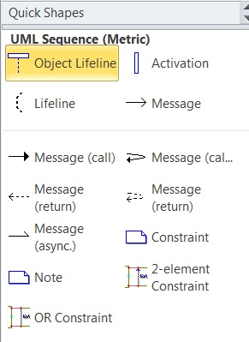

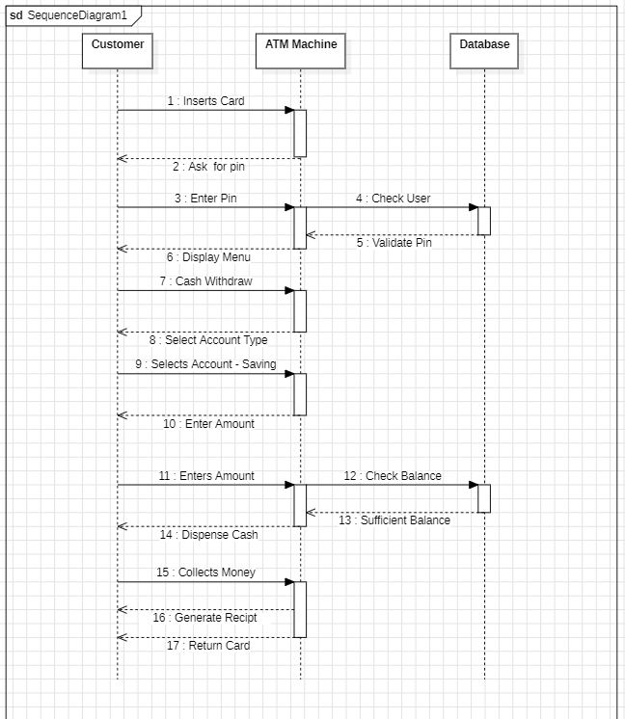

**EXPERIMENT 4**

# AIM: - To perform the class diagram for suggested system: Activity Diagram

An activity diagram is a behavioral diagram i.e., it depicts the behavior of a system.

An activity diagram portrays the control flow from a start point to a finish point showing the various decision paths that exist while the activity is being executed. We can depict both sequential processing and concurrent processing of activities using an activity diagram. They are used in business and process modelling where their primary use is to depict the dynamic aspects of a system.

An activity diagram is very similar to a flow chart. So let us understand if an activity diagrams or flowcharts are any different.

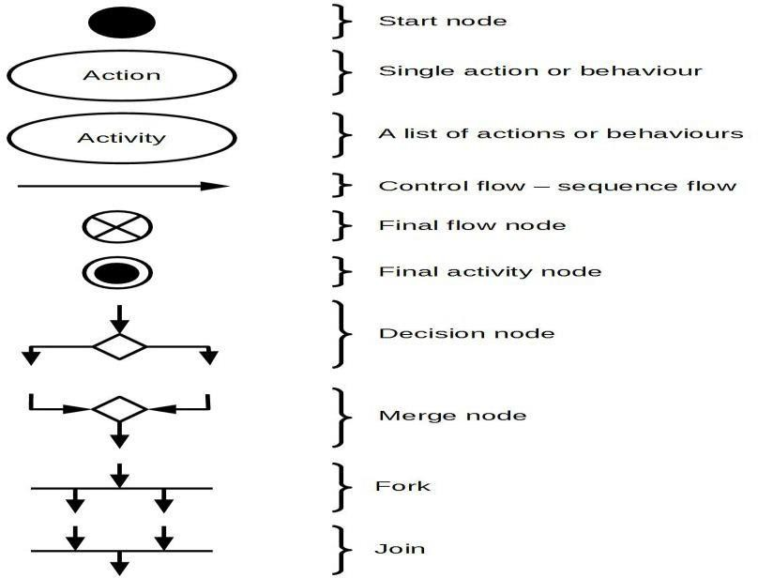

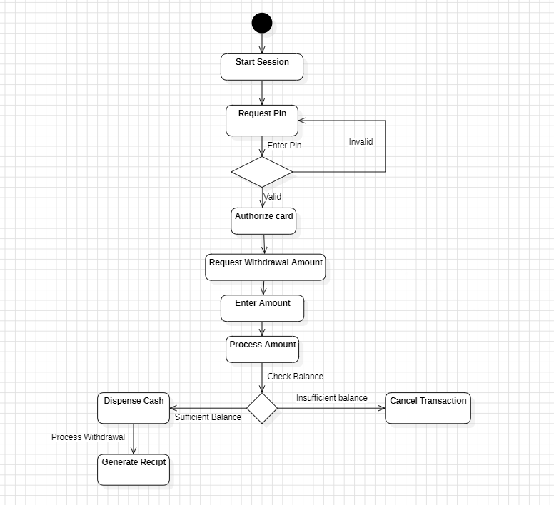

**EXPERIMENT 5**

**AIM: - To perform the class diagram for suggested system: Class Diagram**

Class diagram is a static diagram. It represents the static view of an application. Class diagram is not only used for visualizing, describing, and documenting different aspects of a system but also for constructing executable code of the software application.

Class diagram describes the attributes and operations of a class and also the constraints imposed on the system. The class diagrams are widely used in the modeling of object oriented systems because they are the only UML diagrams, which can be mapped directly with object-oriented languages.

Class diagram shows a collection of classes, interfaces, associations, collaborations, and constraints. It is also known as a structural diagram.

**Purpose of Class Diagrams:**

The purpose of class diagram is to model the static view of an application. Class diagrams are the only diagrams which can be directly mapped with object- oriented languages and thus widely used at the time of construction.

The purpose of the class diagram can be summarized as −

* Analysis and design of the static view of an application.
* Describe responsibilities of a system.
* Base for component and deployment diagrams.
* Forward and reverse engineering.

